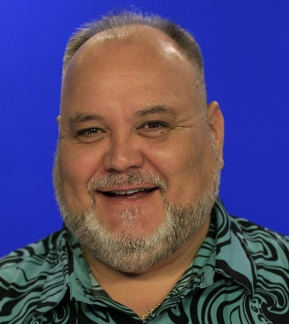
Application Form

ROBERT KEKAULA
MEMORIAL SCHOLARSHIP

Application Deadline: Friday, September 15, 2024

For a broadcast journalism student who is Hawaiian/Native Hawaiian and pursing a degree in May of 2025 or later.

Name: ___________________________________________________________ SS#:__________________________________

Address*: __________________________________________ City/ST/Zip: _________________________________________
* Permanent home address (not school)

Cell Phone: ______________________________ E-mail: _______________________________________________________

College/University: ____________________________________________________________ Academic Year: ____________

Graduation Date: _______________ Degree: _________________________________ GPA:_____________________

Faculty References: (Faculty may e-mail their recommendation to: office@emmysf.tv)

Name:__________________________________ Email:_________________________________ Phone: __________________

Name:__________________________________ Email:_________________________________ Phone: __________________

E-mail the following to: office@emmysf.tv
1 – This Application
2 – Current headshot (jpg)
3 – Transcript (unofficial is ok)
4 – Letters of Recommendation (can be submitted by recommender)
5 – Essay (include the following information)
- Discuss your qualifications for this scholarship and future aspirations in broadcast journalism
- Please include an example of a story or event that helped mold your passion for journalism.
- Long-term, how will your work as a journalist help your community?

VIDEO: (VIDEO sample: Maximum length (TRT) 15 minutes
News story, documentary, personal testimonial, etc. Please indicate TRT, your role, why you chose this video.
http://natasstudentawards.org/entry_login.php?c=7
First click SIGN UP at bottom of page, “Become a guest user” (complete form)
Log in with your e-mail and password – complete entry form:
Category: 504 – Fred Zehnder Memorial Undergraduate Journalism
Entry Title (your name)
Entrants Role
Submitting Organization (your school)
Length (the total TRT of your entry)
Description (list each cut with title, date completed, length, your role and comments)
Upload Video (link at top of log-in page)

Applicant’s Signature: ______________________________________________ Date: __________________

NOTE: Separate application & video is needed to apply for other scholarships.

